Traffic/Public Safety – July 2019 Update
Accident and Speeding Concerns on Westside Road

In 2017 and again in 2018, the Westside Community Association (WCA) petitioned Sonoma County to address speeding and illegal passing concerns on Westside Road. A significant increase in speeding has been noted on multiple sections of Westside Road.

Since WCA’s 2018 letter, two (2) additional accidents, including the 5th accident at the blind curve near 4603 Westside, have occurred.
Request: Again, the WCA requests that County Transportation place “Your Speed Is” electronic monitoring equipment in high risk areas along Westside Road and then increase enforcement.

To learn more about how speeding kills – especially on rural roads with horizontal and vertical curves - click on this link, then download the full Governors Highway Safety report or read the Key Points Summary: https://www.ghsa.org/resources/Speeding19

There are three known deaths and several Westside residents have been seriously injured in the past few years. It’s only a miracle that a bicyclist has not been killed.

Even the Healdsburg Tribune noted the speeding issue with its April 24th picture in the Endnote, titled “Ditched.”

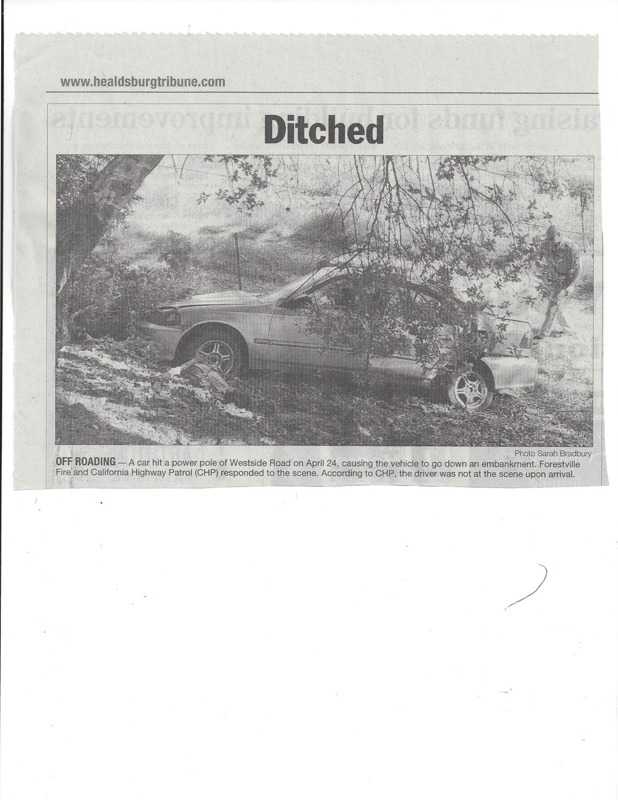
WCA Input relative to 4603 Westside Appeal of Use Permit Denial: On July 23rd the Board of Supervisors will hear the Broken Hills LLC Appeal of a BZA decision to deny a winery Use Permit at 4603 Westside. The WCA requests that the Supervisors affirm and uphold the Board of Zoning Adjustments’ 2017 finding that a winery and event facility in this location will create a traffic/public safety hazard.
Since the 2017 BZA Hearing, there have been several more accidents involving the dangerous road segment around the sharp curve north of 4603 Westside.

This curve, just north of the project entrance is one of the most, if not the most, dangerous curves on Westside Road with over 11 accidents since 1994. Staff reported a total of 7 accidents (1 fatality, 2 head-on) near this curve up to 2015; and in the past two years, there have been several more speeding-related accidents, with 3 occurring after the 2017 BZA decision. The road geometry, sharp curve necessitated by the presence of a hillside and creek, cannot be changed. In addition, distractions from bicycles and slow-moving vehicles and speeding are other reasons to deny a Use Permit due to traffic /public safety hazards.
WCA Letter: Increased accident rates and speeding are considerations of public safety risks that County officials must take into consideration.
In February 2017, the Westside Community Association requested that the County and CHP/ Sheriff’s office address the increase in accidents and speeding. In 2018, Supervisor Gore asked that WCA provide some evidence of recent accidents.

Pictures 1 - 5 Below: A Picture speaks 1000 words: Accidents and Guardrail Damage in Westside’s 4000 block approaching the curve north of 4603 Westside driveway intersection.

On July 11, 2018, there was the fourth accident at the blind curve just before 4603 Westside Road, where a motorcyclist was killed several years ago.

In late summer, 2017, there were two single car accidents in this section of Westside Road. Pictures taken by a local resident show the tire tracks across the opposing lane, and the potential head-on risk created by accidents in this location: The 2017 accidents occurred on August 28, 2017 at 8 PM and on September 3, 2017 red truck had a similar off-road accident.

Pictures 4 and 5 answer the question as to what happened to the guardrail - from speeding-related accidents when vehicles are heading south. Note the guardrail has been repaired, yet remained compromised for guardrail for nearly a year. Guardrail damage pictures alone tell the story of speeding, loss of control and road safety dangers - this blind curve is close to the driveway for Winery Appeal 4603 Westside. Picture 5 guardrail damage was from the most recent accident, July 11, 2018, where the driver was speeding in the section in front of MacRostie Winery and lost control while heading north.

Recent Accidents at other locations: On July 14, 2018 a single car hit the power pole in front of Thomas George winery, taking out power and phone service, and starting a fire that required helicopter drops to extinguish.

This is the 4th known power pole accident in the past year or so; others include a downed power line in front of Westside Farms, and power pole accidents in front of Mill Creek Winery.

July 19, 2018 - Speeding driver exited Matrix Winery and hit and totaled a young neighbor’s car. The white pick-up driver left the scene of the accident, and the CHP took a report.

This is the 2nd time one of our farm workers. our most vulnerable residents, were traveling on Westside road when their vehicles were hit and damaged. Last year’s accident at the Mill Street intersection, was caused by a driver deemed under-the-influence. A CHP report was filed.

